Foxborough Conservation Commission
40 South Street, Foxborough, MA 02035 ~ Tel: 508-543-1251

To: Jane Sears Pierce, Conservation Agent (jpierce@foxboroughma.gov)
From:
Date:
Re: Permit Request for Scouts’ Camping Use of Lane Conservation Area

A copy of this form must be submitted to the Conservation Commission at least 21 days in advance of the date of the proposed activity and is subject to approval by the Conservation Agent and/or Conservation Commission. At the discretion of the Conservation Agent, additional conditions of approval may be required. Submittal of this permit request form does not constitute approval, but if the Conservation Agent has not contacted you within one week of submission, this permit is approved.

Name of Organization/Applicant:
Email:
Dates & Times Requested
Start Date & Time: End Date & Time:
A permit is being sought to hold a scout camping event at the Lane Conservation Area.
Size of Group: Scouts (ages - ) and Adults
Name of Responsible Party/Leader in Charge:
Complete Mailing Address:
Contact Number for Responsible Party:
Please provide a number where you may be reached on the day of your event. This number will not be shared, but may be used regarding land use on the day of your event.
Vehicle Make and Model:
Vehicle License Plate #:
Logistics (please refer to Lane Homestead map, next page, and add hand drawn locations):
Parking Area:
Latrine Pits (must be located more than 200 feet from water, camp and trails):
Number of pits: Location of pits:
Tent Set Up Area (use Lane Homestead map campsite location):
Campfire Area:
The Responsible Party/Leader in Charge Shall:
- Visit the Town Hall’s Conservation Office to pick up the security “gate” key ($20 security deposit).
- Call Foxborough Fire and Police to notify them of the Scouts’ camping plans.
- Follow the Scouts’ “leave no trace” guidelines.
- Carry in and carry out all equipment, trash, etc. (please note that no vehicles are allowed on-site, except initially to transfer camping equipment for set up and at the end to remove equipment).
- Ensure that all vehicles are parked in an approved parking area.
- Please help the Commission by cleaning up and hauling out any trash or debris found in the area.
- Follow the Foxborough Conservation Land Rules and Regulations (attached).
Permit Request for Scouts’ Camping Use of Lane Conservation Area Page Two
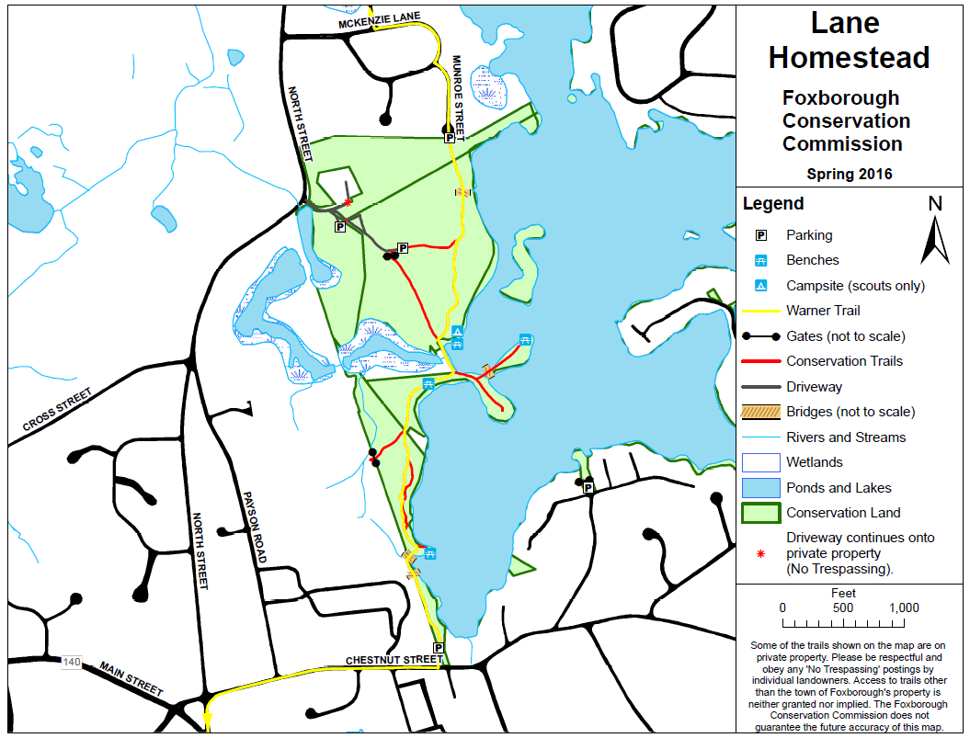
Terms & Conditions
This permit, if approved, must be carried by the Responsible Party/Permittee and may be revoked if the user(s) do not follow these conditions.
In case of emergency, please call:
Foxborough Police Department: 508-543-4343 and/or
Foxborough Fire Department: 508-543-1238
I (Permittee) hereby certify that I have read and understood the Foxborough Conservation Land Rules and Regulations (attached) and agree to abide by them. The Permittee shall indemnify and save harmless the Town of Foxborough and all of its officers, agents and employees for any suits, causes of action, claims, judgments or other liability, including without limitation reasonable counsel fees and expenses that may arise as a result of Permittee’s use of Town Conservation Land.
The Permittee may be required to provide to the Town of Foxborough, prior to the date of use of Town property, a certificate of insurance evidencing that the Permittee carries insurance with a licensed insurance company acceptable to the Town. Such insurance shall name the Town of Foxborough as an additional insured and shall not be cancelled or modified prior to the completion of use of Town property.
I agree to the terms and conditions above.

___________________________________________
Signature of Responsible Party/Permittee
Foxborough Conservation Land Rules & Regulations
Foxborough conservation land is managed by the Foxborough Conservation Commission (“Commission”) for passive or recreational activities, where appropriate, as well as to promote biodiversity. The Commission and the Conservation Agent (“Agent”) are tasked with maintaining, enhancing and/or conducting studies on conservation lands and are exempt from these Rules and Regulations.
- Hours / Trails
- Conservation land is open year-round from 1/2 hour before sunrise to 1/2 hour after sunset, unless authorized by the Commission or the Agent.
- The cutting of trails and erection of signs is prohibited without the Commission’s written approval.
- During “mud season” or for other environmental reasons, trails may be closed without prior notice; trail closure notifications will be posted on the Commission’s website.
- Property
- The dumping of yard waste and debris is prohibited.
- Carry out what you carry in; littering and/or dumping of any materials are prohibited.
- Possession of alcoholic beverages or glass containers is prohibited.
- Metal detectors are not allowed; removal of artifacts is prohibited.
- Vehicles
- The operation of motor vehicles including, but not limited to, motorcycles, dirt bikes, ATVs, OHVs, and snow-mobiles is prohibited (see Foxborough Code, Part II, Ch. 256).
- Vehicles should park in designated parking areas or, where unavailable, safely along public roads.
- Parking after authorized hours is prohibited, unless permitted by the Commission or Agent.
- Animals
- Control of pets must conform to the Town’s animal control laws (Foxborough Code, Part II, Ch. 78).
- The collection of wildlife is prohibited.
- The introduction of any non-native wildlife is prohibited.
- Target shooting and trapping are prohibited.
- Hunting is not allowed on the Lane Homestead Property or the Neponset Reservoir.
- Plants
- The removal, cutting or damaging of trees, shrubs, plants, flowers and/or fungi is prohibited.
- The collection of plants is prohibited.
- The introduction of non-native plants is prohibited.
- Group Activities and Camping
Group activities (ten or more people) are allowed on conservation land only after obtaining specific written permission from the Commission.
A completed “Request for Group Use of Foxborough Conservation Land” application must be submitted to the Commission at least 21 days in advance of any proposed group activity. Application forms are available online and at the Foxborough Town Hall. Completed applications must include (a) evidence that the Chief of Police has been notified of the proposed group activity, and (b) if a fee is to be charged for a group event, proof of insurance liability coverage.
The following activities may be allowed with the Commission’s written permission:
- Group activities such as scouting events, classes of instruction, picnics, weddings, outdoor dances, business lunch meetings and other similar events.
- Recreational activities such as foot races, hikes, orienteering, skating, etc.
- Camping or similar use.
- Use of land for agriculture or forestry.
- No open fires or cooking fires, without written approval of both the Commission and the Fire Department (see Lane Learning Center Fire Pit Rules, next page).
- Organized or commercial events, which charge fees or raise or collect funds for any purpose.
If a group activity has been approved, the Commission’s written permission must be carried by the person in charge of the event at all times during the event.
- Additional Important Information
- The Commission reserves the right to amend these regulations and to prohibit any inappropriate activities, not specifically listed above.
- You are entering upon the land at your own risk. Neither the Town of Foxborough nor private landowners assume any liability for injuries to persons or damage to their property while on conservation land.
- These regulations will be enforced by the Foxborough Police Department, the Commission, the Agent (who is authorized to act on behalf of the Commission), and/or the Forest and Park Supervisor of the F. Gilbert Hills State Forest.
- Copies of all current regulations are available online and at the Foxborough Town Hall.
- If you have any questions or comments, please contact the Agent at the Town Hall. In the case of an emergency, please call the Foxborough Police at 911.
- Please enjoy your visits to the conservation lands of Foxborough. These regulations have been published for your benefit, safety, and enjoyment of conservation lands.

Thank You! It’s Your Land… ENJOY IT!

Lane Homestead Learning Center
Fire Pit Use Guidelines

- Before beginning to use the Learning Center’s fire pit, you must obtain:
- Approval from the Conservation Commission (after completing this form), and
- Permission from the Fire Department (508-543-1230).
- Adult supervision is required at all times.
- Never leave any fire unattended.
- Please bring your own supply of local firewood and remove unused wood or stack it in the hoops.
- At least 5 gallons of water must is available at all times during fire pit use. Water can be drawn from the rain barrels, using the metal buckets that are next to the rain barrels.
- Do not stand on the fire pit walls.
- Bring a metal rake; soak and then spread out coals with your rake after the event to be sure that the fire is completely out.
- Leave area free of trash and any debris.
- Please return the metal buckets to where they were found.

Please Note:
Use of the Lane Learning Center Fire Pit is at your own risk; the Town of Foxborough and the Friends of Foxborough Conservation shall bear no responsibility for any bodily injury or personal property damage that may result from its use.

